[Skya Photostable Matt Sunscreen Lotion](https://skyatransdermic.com/products/photostable-matt-sunscreen-lotion)

Are you looking for a sunscreen that moisturises your skin while protecting you from harmful ultraviolet rays but is also cruelty-free? The Skya Photostable Matt Sunscreen Lotion is a bottle packed with many benefits including these. The sunscreen is an advanced formula providing broad-spectrum protection against harmful UVA and UVB rays. Made of photostable ingredients, the components of the lotion are carefully chosen so that they do not degrade on exposure to sunlight. This does not just make it effective but also enhances the longevity of its effect on the skin. Owing to its mattifying effect, the sunscreen does the job without making the skin look greasy and blocking the pores. Its mattifying effect also helps control the shine of the skin and does not let a thin film of product develop on the skin.

**DETAILS**

**Composition:**

Purified Water, Octocrylene, Tris -Biphenyl Triazine, Octisalate, Isoamyl Laurate, Hydrogenated Polydecene, Glycerin, Propanediol , Bis - ethylhexyloxy phenol methoxyphenyl triazine, Neopentyl Glycol Diheptanoate,Microcrystalline Wax, Cetearyl Alcohol, Caprylyl Methicone, PPG-1 Trideceth-13, Sodium Acrylates Copolymer, Aloe Vera Extract, Tocopheryl Acetate (Vitamin-E), Dimethicone, Phenoxyethanol ( and ) Ethylhexyl glycerin, Tetrahydrocurcumin, Silica, Xanthan Gum, Potassium CetylPhosphate, Sodium Hydroxide, Fragrance.

**Know your product:**

* **Octocrylene: Organic UV filter with water resistance properties**

An oil-soluble liquid, Octocrylene is a thick, colourless ingredient commonly used in anti-ageing creams and sunscreens. It protects the skin against the harmful effects of the sun’s UV rays that pose a cancer threat. Due to its emollient properties, it moisturises the skin and its hydrophobic nature improves the water resistance of products. Octocrylene is used more effectively in combination with the other ingredients of the sunscreen to maintain enhanced photostability while providing a higher SPF.

*Source: <https://www.medicalnewstoday.com/articles/octocrylene#benefits>

* **Tris-Biphenyl Triazine: A nano but potent photostable UV filter**

Tris-Biphenyl Triazine boasts of being the most efficient UVB and UVA2 filter known today. A broad-spectrum filter that not only offers remarkable photostability but also offers advanced SPF performance at low concentration. UVA2 (320-340 nm) is an easily missable spot that this ingredient helps bridge along with the combined sunscreen formula so as to cover the whole UV spectrum. A hybrid agent; that falls between chemical and physical sunscreens, the ingredient exists in the nano form – micro fine particles that are organic in nature.

*Source: <https://incidecoder.com/ingredients/tris-biphenyl-triazine>

* **Octisalate: Absorbs UVB rays decreasing the risk of skin cancer**

Octisalate is an ester of salicylic acid and 2 ethylhexanol. The salicylate abilities of the combined molecule effectively absorb ultraviolet light, protecting the skin from the harmful effects of the sun’s UV rays. The ethylhexanol properties render emollient effects to this oil-soluble sunscreen agent. The ingredient is commonly used to augment the UVB protection in a sunscreen as it has a good safety profile. It also protects against the risk of skin cancer in addition to fighting the signs of ageing and keeping sunburns at bay.

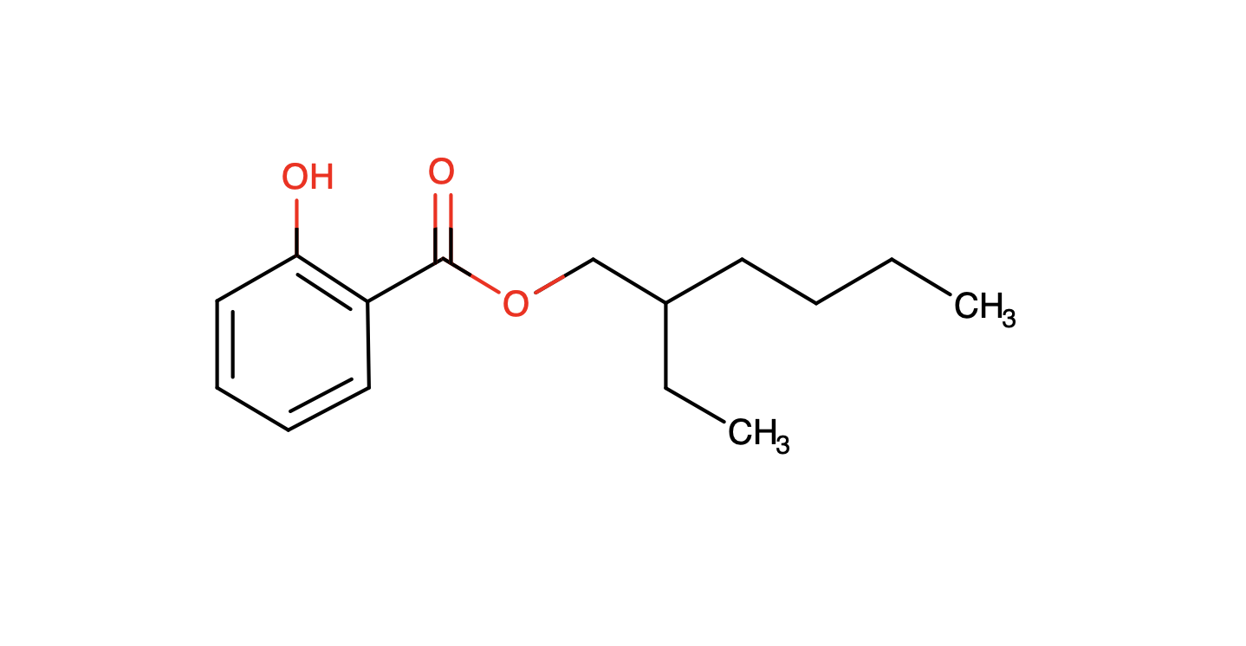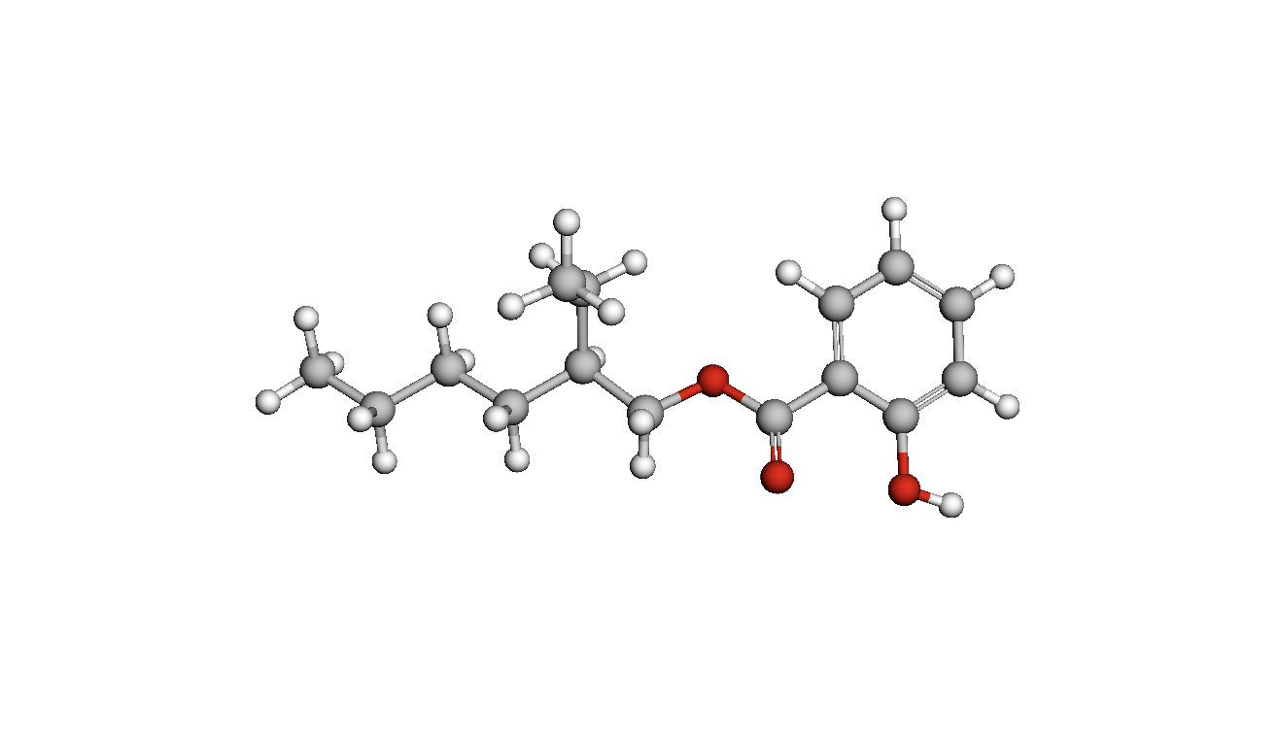

*Source: <https://go.drugbank.com/drugs/DB11062>

* **Bis-Ethylhexyloxyphenol Methoxyphenyl Triazine: An organic oil-soluble sun filter**

Touted as a new-generation sunscreen agent, it offers the highest sunscreen protection amongst many other agents that are commonly used in sunscreens. Designed to provide high SPF and excellent UVA protection, this ingredient is an oil-soluble yellowish powder that is not fully absorbed into the skin. This makes it all the more efficient as a sunscreen agent works best while fighting off the sun’s UV rays from the surface of the skin. Equipped with a good safety profile, it is not known to show any estrogenic activity and hardly deteriorates in the presence of UV light. It also helps to stabilise other less stable sunscreen agents while offering a broad spectrum covering the whole UVB and UVA range (280-400 nm).

*Source: <https://incidecoder.com/ingredients/bis-ethylhexyloxyphenol-methoxyphenyl-triazine>

* **Tetrahydrocurcumin (THC): Ensures deep skin penetration and alleviates atopic dermatitis**

A polyphenolic compound, Tetrahydrocurcumin is a hydrogenated metabolite of curcumin.

It is derived from curcumas, which is the main component of turmeric. A popular phyto-whitening ingredient used in skincare formulations, it is antioxidative in nature and also has anti-inflammatory properties. Offering protection from the harmful UV rays of the sun, Tetrahydrocurcumin is produced through micro emulsification.

*Source: <https://www.ulprospector.com/en/asia/PersonalCare/Detail/29751/998732/Tetrahydrocurcumin-THC>

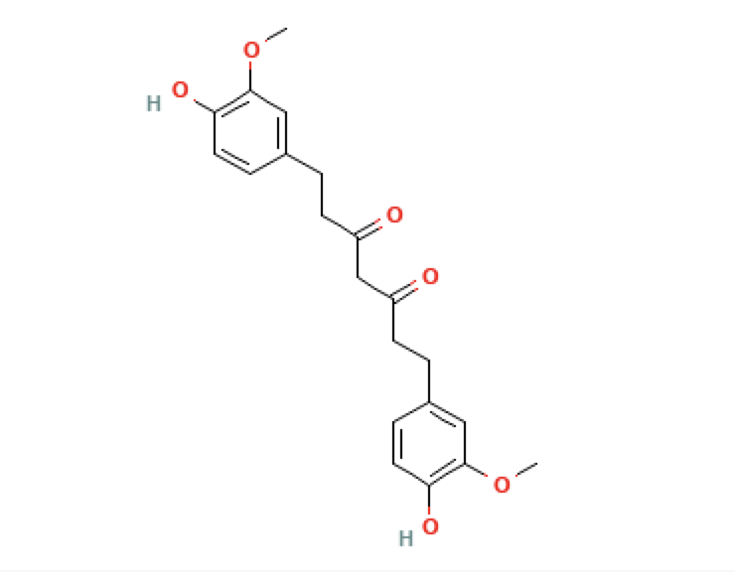

*Source: <https://pubchem.ncbi.nlm.nih.gov/compound/Tetrahydrocurcumin#section=Structures>

**BENEFITS**

* Suitable for all skin types
* Water-resistant
* Cruelty-free
* Provides firmness and vitality to the skin
* Protects your skin cells from free radicals
* Acts as an additional cell protector
* Combats the photoaging causing UVB rays
* Prevents sunburns by protecting against the harmful UV rays
* Lightens the skin tone making the skin look healthier and radiant

**HOW TO USE**

Step I: Squeeze a small amount of the lotion on the tips of two fingers

Step II: Apply a liberal amount on clean face, neck, and other sun exposed areas of the skin

Step III: Reapply after heavy sweating or activities like swimming